**R Code for Examples in the book**

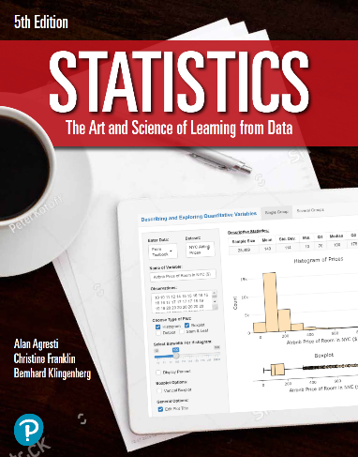

***“Statistics: The Art and Science of Learning from Data”***

**by Agresti, Franklin and Klingenberg, 5th edition**

**Chapter 7**

**Example 3: Election Outcomes - Normal Shape of the Sampling Distribution**

## Reading in voter data

p <- 0.538   
n <- 3889

## To find the mean and standard deviation of the sampling distribution

mean <- p   
stdev <- sqrt((p * (1 - p)) / n)

## To compute the interval of possible sample proportions within 3 standard deviations of the mean

mean + c(-1, 1) * 3 * stdev

## [1] 0.5140164 0.5619836

## To compute the interval of possible sample proportions within 2 standard deviations of the mean

mean + c(-1, 1) * 2 * stdev

## [1] 0.5220109 0.5539891

## To compute the interval value for the plausible values for the actual population proportion

phat <- 0.531  
se <- sqrt((phat * (1 - phat)) / n)  
0.531 + c(-1, 1) * 3 * se

## [1] 0.5069931 0.5550069